MED D Blue MedicareRx (NEJE) - Process for Good Cause Determinations - For Non-payment of Part D-IRMAA

Overview of Plan Policy and CMS Requirements
Process for Good Cause Determinations for Non-Payment of Part D-IRMAA Amounts
Process for Care - Disenrollment for Non-Payment of Part D-IRMAA Amounts
Related Documents

Description: Good Cause Reinstatement guidance for NEJE for nonpayment of Part D-IRMAA.

Overview of Plan Policy and CMS Requirements
If an individual has been involuntarily disenrolled for failure to pay Part D-IRMAA, they may request a review of this decision if they (or their payer) had an uncontrollable circumstance or event that they could not foresee which prevented them from paying their Part D-IRMAA within the grace period.
- Refer to Process for Care - Disenrollment for Non-Payment of Part D-IRMAA Amounts

Examples of circumstances that may constitute a good cause reinstatement for Part D-IRMAA (routed through CMS):
- For disenrollments effectuated by CMS for failure to pay Part D-IRMAA, Federal government error (i.e., CMS, SSA or RRB) caused the payment to be incorrect or late, and the beneficiary was unaware of the error or unable to take action prior to the disenrollment effective date.

Top of the Document

Process for Good Cause Determinations for Non-Payment of Part D-IRMAA Amounts
CMS holds responsibility for billing and collection of Part D-IRMAA amounts.

When a disenrolled individual contacts the plan sponsor following disenrollment for failure to pay Part D-IRMAA and indicates that they had an emergency or a good reason for not paying the Part D-IRMAA, the CCR must:

- Advise the individual to contact Medicare within 60 calendar days of the disenrollment effective date to make the good cause reinstatement request at 1-800-MEDICARE (1-800-633-4227)
  - TTY users should use: 1-877-486-2048.

- The CCR should also inform the individual that in order to be reinstated, they must meet specific good cause standards and must pay any past due plan premiums and Part D-IRMAA amounts within three (3) months of the disenrollment date in order for reinstatement to occur.

- Once a request is made with CMS via 1-800-MEDICARE, a Complaint Tracking Module (CTM) case will be generated for CMS caseworker action.

- The CMS caseworker will review the request and will make a favorable or unfavorable good cause determination.

CCR Process Note: If the individual provides any documentation to the plan regarding the inability to make timely payment of the Part D-IRMAA, the plan must provide that documentation to CMS.

- If CMS makes a favorable determination, a notation will be made in the CTM and the CTM will be sent to the plan.
  - If there are past due plan premiums as well, the plan will send notification to the individual requesting payment of the past due plan premiums within three (3) business days of being informed of the favorable good cause determination.
  - This notice will be sent only if when there are past due plan premiums and specify the amount owed with the date the payment must be received.

Top of the Document

Process for Care - Disenrollment for Non-Payment of Part D-IRMAA Amounts
The CCR should perform the following when receiving a call from an individual who has been:
- Disenrolled by CMS for non-payment of PART D-IRMAA amounts
- States they had an emergency that kept them from making their payment on time
AND
- Is requesting review of the decision

The CCR should not make any promises of reinstatement to the beneficiary during this discussion.

Step | Action
1 | - Confirm the reason for disenrollment is non-payment Part D IRMAA  - Confirm that the caller is contacting the plan within 60 days of the disenrollment effective date  Note: If the reason for disenrollment is other:  - Plan Error: The plan may need to review if an error has been made in billing or calculating payments, the plan may reinstate the enrollee due to “plan error”, but this is not considered a Good Cause reinstatement.  - Federal Government Error: Disenrollments effectuated by CMS for failure to pay Part D-IRMAA, CMS may reinstate the enrollee due to “Federal Government Error”. This occurs when the Federal Government (i.e., CMS, SSA or RRB) caused the payment to not be applied and the enrollee was unaware of the error or unable to take action prior to the disenrollment effective date. This would be considered a Good Cause reinstatement.  - Advise the individual that they MUST contact Medicare within 60 calendar days of the disenrollment effective date to request a Good Cause reinstatement for non-payment for Part D IRMAA at 1-800-MEDICARE (1-800-633-4227)  - TTY users should use: 1-877-486-2048.  - For those beneficiaries who have been disenrolled for non-payment of premiums, on the Main screen of PeopleSafe, the CCR will see NOT ELIGIBLE:  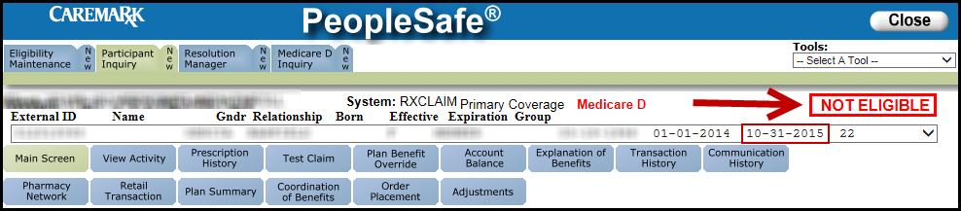  - Disenrollment Effective Date:  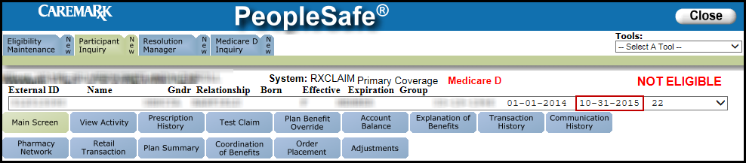  - To confirm the reason for disenrollment is non-payment Part D IRMAA, the CCR should check the following:
1 | In… | Then…
1 | PeopleSafe | Click on the Medicare Part D Inquiry tab.  Result: The Participant Details tab will display.  - On the Participant Details tab, verify the Disenrollment Application date in the Disenrollment Application Date field.  - Click on the View Comments button to review notes pertaining to the beneficiary’s disenrollment.
1 | FACETS | Follow the steps in the MED D - Senior Team - Eligibility in FACETS work instruction.  Click on the View Details tab and review notes pertaining to the beneficiary’s disenrollment.  Note: Notations will have dates on or about the CMS Transaction Line item date.
2 | If the beneficiary or authorized representative has received… | Then…
2 | Notification of Involuntary Disenrollment by CMS for Failure to Pay the Part D-Income Related Monthly Adjustment Amount (Exhibit 21a) | - Medicare disenrolled you from the plan because you did not pay the Part D-IRMAA amount.  - You should contact Medicare within 60 calendar days of the disenrollment effective date to make the good cause reinstatement request at 1-800-MEDICARE (1-800-633-4227).  - TTY users should use: 1-877-486-2048.  - In order to be reinstated, you must meet specific good cause standards and must pay all overdue plan premiums and Part D-IRMAA amounts within three months of the disenrollment date in order for reinstatement to occur.  - Once a request is made to CMS, they will open a case to be reviewed and notify you of the decision.  CCR Process Note:  - An individual who has been disenrolled by CMS for failure to pay Part D-IRMAA remains disenrolled from the plan and does not have access to services until reinstatement occurs and is reported to the plan or the plan is contacted by the CMS caseworker.  - If CMS determines that the enrollee is eligible for a Good Cause reinstatement, and once the enrollee pays the past due Part D-IRMAA amounts directly to CMS, CMS notifies the plan and coverage will be continuous from the disenrollment effective date.  - For employer group plans, the enrollee must continue to be eligible for enrollment in that plan.  Proceed to Step 3.
3 | Ask if there are any other benefit questions.
3 | If… | Then…
3 | Yes | - Address any benefit issues.  - Document and close the call according to current policies and procedures.  - Refer to the MED D - Call Documentation work instruction.  Log Activity: Log Activity/Capture Activity Codes  Resolution Time:  Information = immediately
3 | No | Document and close the call according to current policies and procedures.  Refer to the MED D - Call Documentation work instruction.  Log Activity: Log Activity/Capture Activity Codes  Resolution Time:  Information = immediately

Top of the Document

Related Documents
- Grievance Standard Verbiage (for use in Discussion with Beneficiary) section in MED D - Grievances Index
- Universal Medicare D - Consultative Call Flow (CCF) Process
Parent SOP: CALL-0048: Medicare Part D Customer Care Call Center Requirements-CVS Caremark Part D Services, L.L.C.
Abbreviations/Definitions: Abbreviations / Definitions

Top of the Document
Not to Be Reproduced or Disclosed to Others without Prior Written Approval
ELECTRONIC DATA = OFFICIAL VERSION - PAPER COPY = INFORMATIONAL ONLY

